**Notice to Mariners**

Marine Scotland Science intends to install 31 scientific moorings along the east

coast of Scotland. The moorings will hold research equipment that records echolocation clicks of dolphins and porpoises. Below are a map and a table with the proposed locations of these moorings. Once the moorings are in the water, the locations will be confirmed and updated with as-laid positions. Positions are given in in degrees and decimal minutes (WGS84). We anticipate deploying these moorings between 12 March 2021 – 23 March 2021, and the moorings will be removed in July 2021.

The moorings will have no surface marker, because they are in areas where there is considerable vessel traffic. They will extend vertically no more than 5 metres from the seabed.

All enquiries should be made to the Marine Scotland marine mammal acoustics mailbox ([acoustics@gov.scot](mailto:acoustics@gov.scot)).

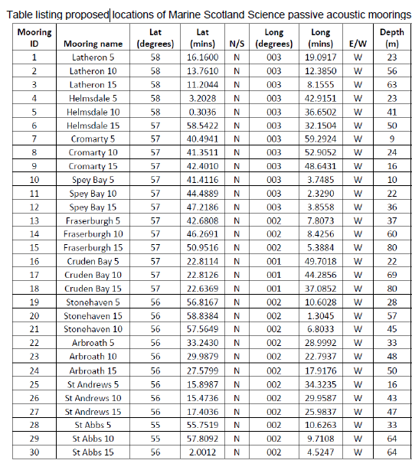

|  |  |  |
| --- | --- | --- |
| **Location** | **Lat** | **Long** |
| Duncansby Head | 58 37.578 N | 003 0.204 W |

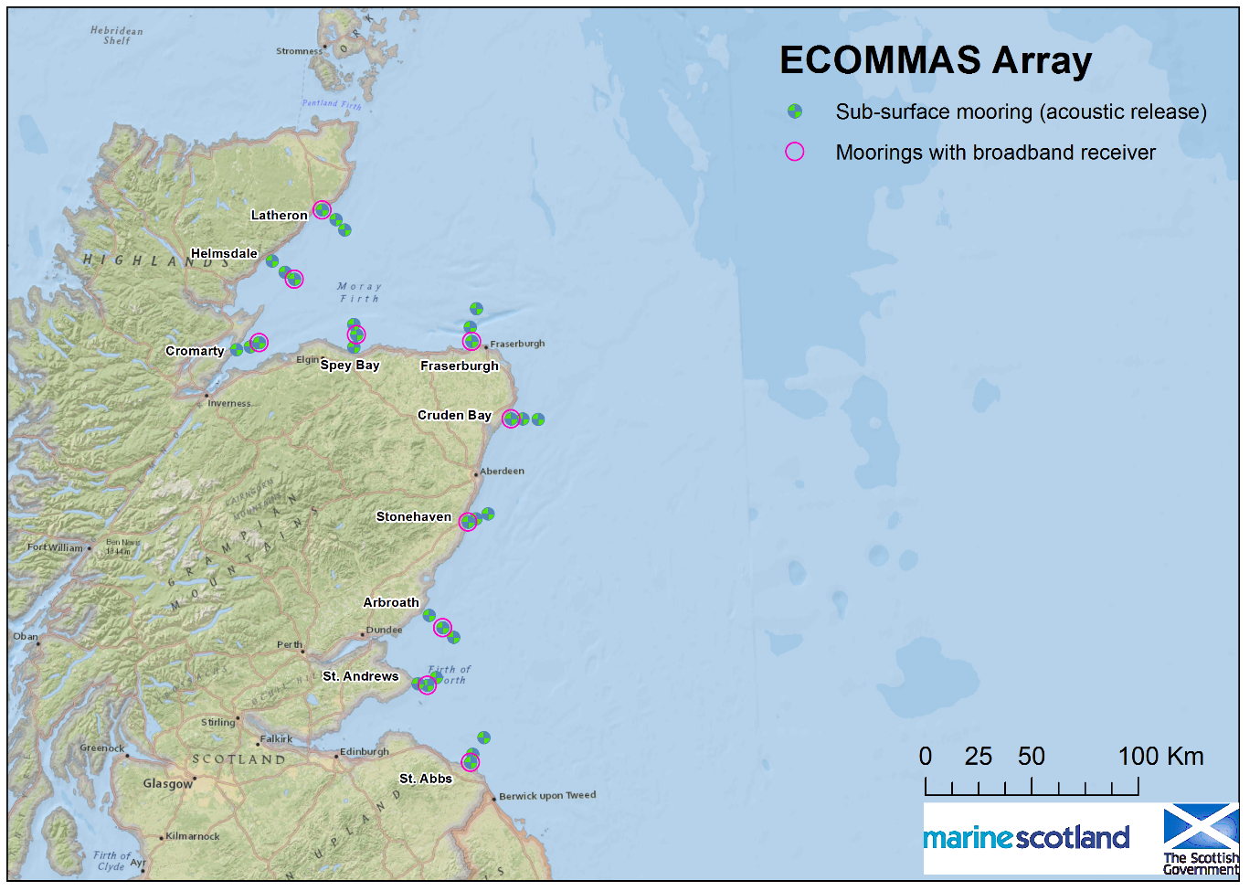

1. Map showing ECOMMAS east coast moorings

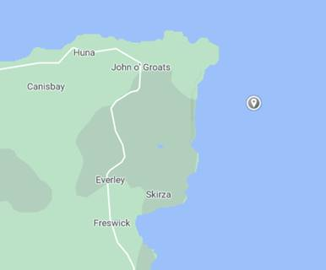

2. Map showing Duncansby Head mooring